Chaouki T Abdallah
Contact
chaouki@unm.edu
Ph: 505-277-2611
Fx: 505-277-8275
Physical Address
Scholes Hall, Room 240
Mailing Address
Office of the Provost
MSC05 3400
Scholes Hall, Room 240
1 University of New Mexico
Albuquerque, NM 87131

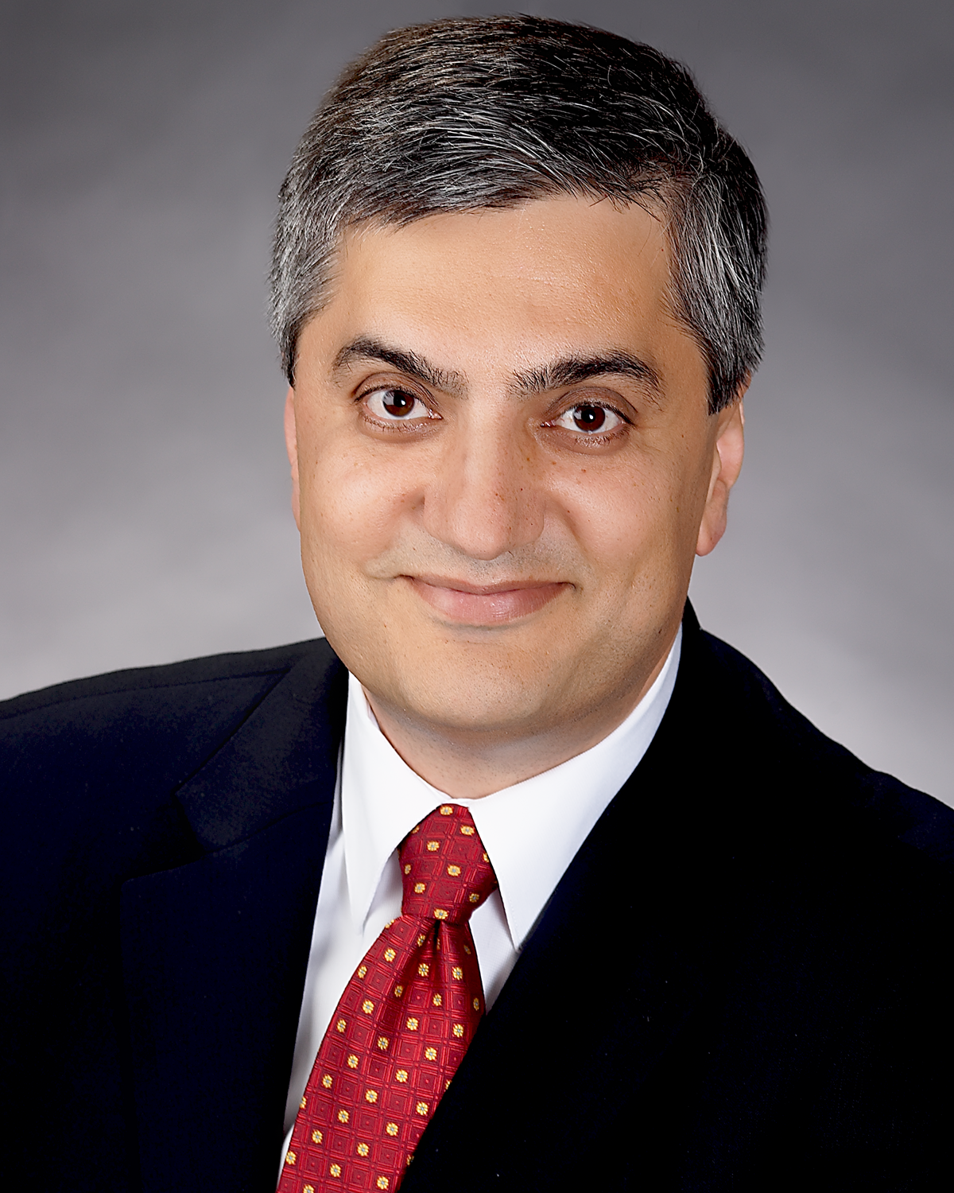Professor
Department of Electrical & Computer Engineering
Personal Website: http://www.ece.unm.edu/faculty/chaouki
Curriculum Vitae (link to PDF)

Education
PhD, Electrical Engineering, Georgia Institute of Technology, 1988
MS, Electrical Engineering, Georgia Institute of Technology, 1982
BE, Electrical Engineering, Youngstown State University, 1981
Biography
Chaouki T. Abdallah started his college education at the Ecole Supérieure d'Ingénieurs de Beyrouth - Université Saint-Joseph in Beirut, Lebanon, but finished his undergraduate studies at Youngstown State University, with a Bachelors of Engineering degree in Electrical Engineering in 1981. He then obtained his MS and Ph.D. in Electrical Engineering from GA Tech in 1982, and 1988 respectively. He joined the Electrical and Computer Engineering department at the University of New Mexico where he is currently professor and Provost of the University. He has published 7 books, and more than 300 peer- reviewed papers. His PhD students hold academic positions in the USA and in Europe, and senior technical positions in various US National Laboratories. Professor Abdallah is a senior member of IEEE and a recipient of the IEEE Millennium medal. He is also active in the IEEE Control Systems Society most recently serving as the general chair of the 2008 Conference of Decision and Control CDC 2008
Teaching Interests
- Control Systems
- Complex Networks
Research Interests
- Control Systems
- Robotics, Networks
Center/Laboratory/Program Affiliations

