Promotion and Tenure Q&A
Updated January 2025

Q: What is the tenure process and where do I find more information?

A: The SOE policy (https://engineering.unm.edu/faculty/resources-for-faculty.html) and this Q&A document are consistent with the P&T guidelines of the Office of Academic Affairs (the Provost’s office) including the COVID-impact guidelines which are updated annually.

The Academic Affairs P&T Guidelines are here: https://provost.unm.edu/promotion-and-tenure/guidelines/provosts-promotion-tenure-guidelines/index.html

Here is a visual explanation of the tenure timeline. Your dossier will be reviewed by your department (P&T Committee, eligible voting faculty colleagues, and Chair), the School of Engineering (SOE P&T Committee and the Dean), and the provost office (PARC committee, SVP, and Provost). University due dates are in the Academic Affairs P&T Guidelines. Each School or College will set an earlier deadline, and each department will also set a deadline for candidates to submit their portion of the dossier.

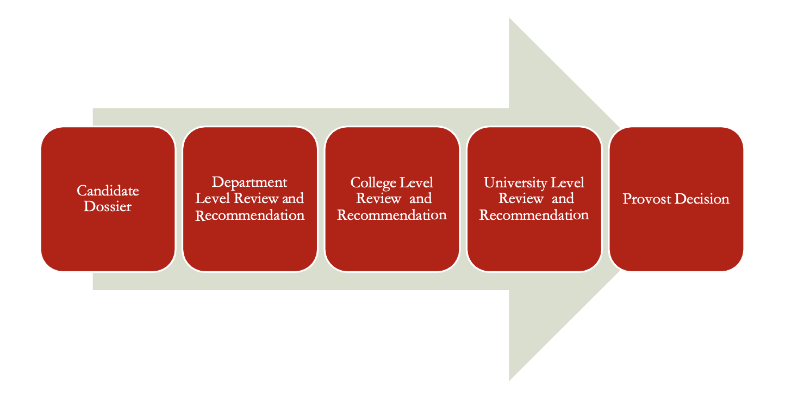

Q: Should I provide a summary of my major accomplishments?

A: Yes! There is not a place to upload a summary document to the RPT submission site. However, the SOE asks you to include a cover page summarizing your major accomplishments as the first single page in your CV. Candidates and reviewers should keep in mind that evaluations are holistic and not determined by any particular metric. Candidates should use this summary to briefly highlight, within a single page, their major accomplishments in the areas of research, teaching, and service. This is not a full list of activities but should be thought of as an abstract that highlights key strengths from the full dossier. Below are some items to consider including in the summary page:

- Brief highlights of research
  - # of peer-reviewed journal publications
  - # conference publications (and # peer reviewed) as well as other publications
  - A single statement summarizing total funding awarded to UNM in your sponsored research and brief examples of major sponsors or funders (i.e. NSF, DOE, DOD and industry).
  - # graduated PhD students, # of graduated research MS students, and # of research undergraduate advisees
  - # current PhD, MS & undergraduate research advisees
  - # patents issued and disclosed
  - h-index and # citations of publications with date and source of query
- Highlights of teaching
  - Summary of distinct courses taught and an average of teaching evaluation scores (on Q1 and Q2) over all courses
  - A single statement of major teaching innovations and approach that support student learning and success
- Major awards (i.e., SOE junior teaching award, IEEE Fellow, or CAREER award). Other funding awards are not intended to be listed here
- Particularly impactful service or outreach activities at the community, scientific community, department, School, or university level
The above is intended to be guidance rather than an exact format. Candidates should use their judgement to best highlight their strengths using quantitative and qualitative summary statements.

Q: How should I summarize my teaching evaluation scores?

A: The Academic Affairs P&T Guidelines document has a table to upload teaching evaluation scores for each course you have taught. The Academic Affairs Guidelines asks you to upload summaries for the last 6 years for tenure cases. SOE level review will place emphasis on teaching scores from courses taught since the last milestone review (e.g., 3 years since mid-probationary review for typical tenure cases, or 5 years since P&T review for typical promotion to full professor cases).

Please use the Teaching Summary Table (Appendix C) of Academic Affairs P&T Guidelines to report teaching evaluation scores. Note that only 2 questions are required from EvaluationKit: Q1 = Rate the Instructor’s Overall effectiveness and Q2 = How comfortable do you feel approaching the instructor with questions? Q6 is not asked nor required in the SOE. Enter N/A on the Academic Affairs form.

Q: Do I upload all student comments on teaching evaluations?

A: Yes. The Academic Affairs P&T Guidelines ask that all student comments from all classes be uploaded from the most recent 6 years for tenure cases. Combine student comments into one PDF for each course. The SOE will focus evaluation on student comments from courses taught since the last milestone review (e.g., since mid-probationary review for typical tenure cases, or since P&T review for typical promotion to full professor cases).

The School of Engineering recognizes that student evaluations can perpetuate bias. If racist, sexist, or other discriminatory language or personal attacks appear in student comments, you may work with your Department Chair to redact those comments. Redactions are anticipated to be rare and should not be used to remove comments simply because they are negative (i.e. “This professor is terrible because they always return homework late” is not a comment that can be redacted even if the professor disagrees with it.) Redacted comments should be replaced with <comment redacted>. The comment should be reported by the Department Chair to the SOE administration via the Associate Dean for Faculty Affairs in order to keep a record of such comments and ensure that standards for redactions are fair across departments.

Q: How many peer teaching evaluations do I need?

A: One per year, arranged by your department Chair. These are evaluations by peer faculty members, typically by more senior faculty members in your department, after meeting with you and observing your teaching in the classroom or lab. Peer evaluators should use the SOE peer teaching evaluation guide (found in the “attachments” document here: https://engineering.unm.edu/faculty/resources-for-faculty.html). The Academic Affairs P&T Guidelines ask for one peer teaching evaluation for each academic year. Prior to 2022, the SOE required only 1 peer evaluation for candidate dossiers. Beginning in 2022, one peer evaluation per academic year is be expected for SOE candidates, in line with the Academic Affairs guidelines.

The peer teaching observation and evaluation process is intended to be helpful to the faculty candidate by providing feedback to the faculty member. We highly encourage faculty members to take advantage of the excellent midsemester student-feedback (https://ctl.unm.edu/instructors/teaching-feedback/mid-course-student-feedback.html) and teaching observations (https://ctl.unm.edu/instructors/teaching-feedback/teaching-observations.html) services provided by the Center for Teaching and Learning (CTL) (https://ctl.unm.edu/).

Services provided by CTL can be used in lieu of peer teaching observations so that a mix of peer teaching evaluations and documentation of CTL’s services can be used in P&T dossiers. Please discuss with your Chair about an appropriate mix of evaluations for your P&T case might look like.

Q: The SOE policy says teaching evaluations should be confidential. What does this mean?

A: The peer faculty evaluation does not need to be confidential (see above); it should be shared with the candidate to provide feedback and is part of the internal UNM P&T packet.

Q: The Academic Affairs P&T guidelines ask for examples of original teaching materials from each unique course taught (no need to include materials from the same course taught over several semesters). How long should this section be?

A: This section should include a short example of materials from each course (a few pages per course, e.g. a syllabus, lecture notes, or exam). Think through what you want to include - the purpose of the materials is to provide evidence of excellence in teaching which includes how you support student learning and success. You may include a list of the materials at the start of this section. Since the material is before your research statement in the RPT system, it is distracting to include lengthy materials. If desired, extended materials can be included in supplemental material. See FAQ below for more guidance on what should (and should not) be included in supplemental material.

Q: What is required to come up early for tenure?

A: The Faculty Handbook and Academic Affairs R&T guidelines establish additional criteria for early tenure. Early tenure is not encouraged, but the SOE supports early tenure for rare, exceptionally strong cases.

See “Guidelines for Managing Shortened Tenure Clocks” (https://provost.unm.edu/promotion-and-tenure/guidelines/provosts-promotion-tenure-guidelines/index.html) and Academic Affairs P&T guidelines for more information on “Early Milestone Reviews”.

Q: What is required to come up early for promotion to Full Professor (earlier than during the typical 6th year post tenure)?

A: The requirements for promotion to Full Professor is the same if the evaluation period is shortened (typically by one year). Early promotion may be appropriate if a candidate meets all of the requirements for Promotion faster than is typical. Candidates should consult with their chair to establish whether early promotion is appropriate for their case.

Q: How should I include unpublished research?

A: The Academic Affairs P&T guidelines outline that published and accepted papers should be included in the CV. Submitted manuscripts should be listed separately. Note that long lists of manuscripts that have been recently submitted but not accepted are not viewed favorably. Manuscripts in preparation that are not yet submitted should not be listed on the CV.

Q: My tenure/promotion/mid-pro evaluation period includes the 2020/2021 and 2021/2022 academic years. How does the COVID policy impact my tenure clock and expectations?

A: This memo addresses tenure clock extensions due to the COVID-19 pandemic. COVID-19 Impact Guidelines are also included in the Academic Affairs P&T Guidelines.

Faculty are automatically granted an additional year on tenure and mid-pro evaluations (on top of any parental or sick leave extensions) for faculty hired until January 2021. You may opt out of this additional year following instructions in the Academic Affairs P&T guidelines. You will not be evaluated differently for taking extensions.

Additionally, note that Student Evaluations of Teaching (SETs) for Spring, 2020, Fall 2020 and Spring 2021 is optional. Please see FAQs above about summarizing teaching evaluation scores and comments.

If your tenure case is impacted by the COVID-19 pandemic, this should be explained in your statements. For example, if you faced delays in setting up a lab, recruiting graduate students, having publications reviewed or having grants funded, or graduating Ph.D. students, this may be explained in your research statement.

Q: Will I be denied tenure if I have not advised a doctoral student who has graduated or is close to graduation?

A: It is an expectation in the SOE P&T Policy that for promotion to the Associate Professor level you have a demonstrated record of graduating doctoral students. Demonstrating graduate student progress toward graduation is an indicator of research excellence.

However, each tenure case is considered individually and research excellence is evaluated holistically. SOE and departmental tenure committees will take into consideration special circumstances, for example if COVID caused substantial delays in graduate research, or if a graduate student left the program. In addition to PhD students graduated, another important consideration for the tenure and promotion committees is graduate student pipeline, that is, graduate student progress toward milestone evaluations (i.e., coursework completion, strong publishing track record, passing qualifying exams, passing comprehensive exams, passing dissertation proposal, and granting of candidacy). So make sure for current graduate students, their progress in their Ph.D. programs are clearly indicated.

Q: Should annual performance reviews be included in the department review of a candidate?

A: Yes, full annual reviews should be included in the materials for promotion and tenure. Access to a candidate’s annual reviews is anticipated for anyone who has an official role in the evaluation for tenure status and rank, which includes eligible department voting faculty and the P&T committees (department and school). Reviewers need to know what department chairs told the candidates at earlier annual or mid probationary reviews to know whether the candidate had a clear picture of expectations for and progress toward tenure.

Q: What should I include as supplemental material in my RPT?

A: See the SOE P&T Policy Attachment for a full list of required Supplemental Materials.
Optionally, unpublished manuscripts are acceptable as supplemental material, but only substantive, high-quality submitted manuscripts should be included. Long lists of manuscripts in press or recently submitted are not viewed favorably. Unsolicited letters of support are acceptable (see Academic Affairs P&T guidelines), but they are not allowed after candidate has submitted material to RPT. Additional teaching material can also be included in supplemental material. Supplemental material beyond that required by the SOE is not necessary, and should only be included if it strengthens your packet (i.e., evidence for excellence in teaching). Candidates should discuss this with their department P&T committee. Chairs will approve supplemental material, and they should guide candidates to ensure that they do not submit lengthy material that distracts from the rest of the packet.

Q: How soon after my departmental faculty vote should I expect to hear from my Chair whether my promotion or tenure application was recommended?

A: If the letter is negative, the process in the Faculty Handbook, section B.4.3.6 on Negative Recommendations needs to be followed (https://handbook.unm.edu/b4/).

If the chair letter is positive, it is recommended that that Chair and the Dean let the candidate know of the positive recommendation within a week (the sooner the better). However, it is not the practice, across UNM, to share a positive Chair or Dean’s letter with the candidate. Chairs and Deans write letters with the knowledge that the letter is a confidential document that won’t be seen unless a negative recommendation is sent forward, and in that case, the letter is redacted.

Q: How are external review letters acquired and what is uploaded to the RPT system?

A: The candidate provides a list of 6 potential external reviewers to the Department P&T chair, and the department Chair lists additional reviewers (generally 6) to potentially invite. The list of external reviewers needs to be submitted to the Senior Vice Provost (SVP) for review and approval. After approval from SVP, the department chair invites reviewers following guidance from the template invitation letter. A letter is required from at least 3 reviewers from each list, candidate’s and chair’s, avoiding conflicts of interest and ensuring a majority of letters are from R1 institutions. Finally, the chair will list the reviewers who were invited and those that responded with a letter on the external reviewer form (attached to Academic Affairs P&T Guidelines). The list of reviewers is confidential and will not be shared with the candidate.

Q: The SOE policy states that faculty tenure and promotion votes are secret. Should ballot forms be signed?

A: No, faculty ballots for promotion and tenure are not secret. Faculty members are required to sign and date the ballots as described in Academic Affairs P&T guidelines.

Q. What other advice do you have for candidates?

A: We (SOE P&T committee members) are glad you asked. Below are two general recommendations we have from observations and concerns that surfaced during the deliberations of the SOE P&T committee during the past few years. We want to share these recommendations with you in order to ensure a smooth and fair evaluation of your dossier.

- The substance of the Dossier is the basis for the Committee’s deliberations. Attempts to pad the list of accomplishments or to overwhelm the reviewers with voluminous additions to the Dossier are actually counterproductive and undermine the credibility of the candidates.

- The Committee will scrutinize the list of reviewers and their relation to the candidate. The candidate should not suggest, and the department should not solicit reviewers who may have a conflict of interest with the candidate.

